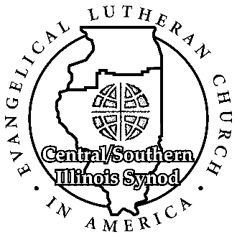
DATE December 2020
Central / Southern Illinois Synod
524 South Fifth Street Phone: 217.753.7915
Springfield IL 62701 Fax: 217.753.7976

TO Ministers of Word and Sacrament
Ministers of Word and Service

FROM Bishop S. John Roth

RE 2020 Report to the Bishop Forms

Thank you for your service to Christ through ELCA rostered ministry. As you know, Ministers of Word and Sacraments and Ministers of Word and Service are constitutionally required to share a report of their ministry with their bishop annually, at least 90 days prior to that year’s Synod Assembly.

Your synod staff strives to do everything possible to enhance the ministries of our congregations and rostered ministers. When the synod office receives your annual report, I will read through it. If you feel you would like to discuss your report or any other matter with me, please call the office and schedule an appointment to meet. I’m happy to discuss any cares and concerns you may have in your service or within your congregation.

USE THE FORM CUSTOMIZED FOR OUR SYNOD;
DO NOT USE THE GENERAL FORM AVAILABLE ON THE ELCA WEBSITE.

You may fill out the enclosed form.

OR

The 2020 Report to the Bishop form can be accessed online:
- www.csis-elca.org
- Hover over “Pastors & Deacons” on the header drop-down bar
- Click on “Annual Reports” in the drop-down menu the appropriate roster
- Click on the appropriate roster category

Please return reports by mail to the synod office or by e-mail to: synodoffice@csis-elca.org

The deadline for returning this document is Friday, FEBRUARY 15, 2021. Please keep a copy for your personal file. These reports become part of your permanent roster file and are important to your ministry.

THANK YOU.

May the glow of the Christ-child continue to light your way in the New Year!

