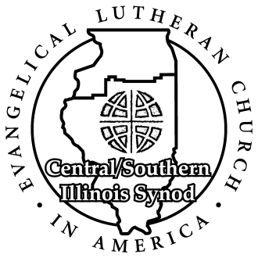

Social Ministry, Justice and Advocacy Committee

Grant Proposal Request Form

Due by April 1st of each Year

Application Date: _______________

Proposal Title:

Project Name:

Sponsoring C/SIS ELCA Congregation: ____________________________________________

Address: ____________________________________________________________________

Email: _____________________________________________ Phone: __________________
Project Organization: ________________________________ Requested Amount: $ ______

Street Address: ____

City, State, Zip: _______________________________________________________________
Chief Executive Officer: __ _______

Proposal Contact Person: __________________________ Title / Role: ___________________

E-mail __________ Phone: ___________________

- Purpose: Brief describe the purpose of the project. Indicate whether the work is in the area of social ministry, justice or advocacy.

- Need: What need(s) is the project designed to address or meet.

- Goals and Procedures: List the specific, measurable goals for the project, and the procedures to achieve them.

- Evaluation: How will outcomes/successess of goals be measured? If the organization has previously received grant money for this project, please include an evaluation.

- Financial Documentation: Please send a budget for this proposal / project, and relevant financial statements of the organization. Electronic copies (spreadsheets, etc.) can be e-mailed with this proposal, or hard copies can be mailed to the synod office. Please make sure statements are clearly marked with reference to this proposal. *NOTE: Grant monies cannot be used for salaries and administrative costs but must be used in the actual project.
- Collaboration: What ELCA C/SIS congregation(s) are partnering with the project as part of their ministry? Describe ways in which the partnership goes beyond financial support and may include volunteers, sharing building space, or providing transformative education.

Please send letter of commitment and involvement from a supporting congregation(s) by e-mail, as well as a copy of the letter with this proposal, or mail a hard copy to the synod office. Make sure it is easy for office staff to match your letters with the correct proposal.

- Other Funding Sources: List other funding agencies to whom you have submitted proposals seeking support of this project.

- Grant Reporting Requirement: After receipt of grant monies it is requested that a letter be sent with a report and photographs (of the project in action): in November (6 mos. period) and April (year end).

The report and pictures need to show how the funds were utilized so that we can keep the Synod and congregations educated as to how the grants are being used to accomplish the ministry of this committee in serving, educating and advocating in our society. This will also help us be able to advocate for more funds in the future as they become available to keep the church strong and working with our communities.

PLEASE email competed proposals and reports to: CentralSouthernSMJA@gmail.com

Mail hardcopies to or contact for more information:
Central / Southern Illinois Synod (ELCA)
524 South Fifth Street | Springfield, IL 62701
Phone: 217.753.7915 | E-mail: synodoffice@csis-elca.org

