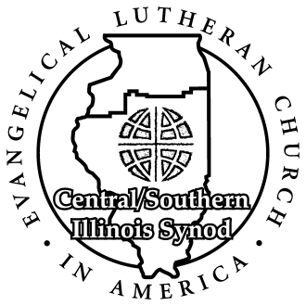

Social Ministry, Justice and Advocacy Committee (SMJA)

Grant Application Information

The Central/Southern Illinois Synod (ELCA) makes grants available for congregations, ministries or community organizations through its for Social Ministry, Justice and Advocacy committee in order to support its mission by serving, educating or advocating on behalf of people in need.

- Grants usually average about $500.

- The Grant Proposal Request Application form is available on the synod website: www.csis-elca.org.

- Grant proposals should follow the form and be limited to three pages in length plus attachments. Proposals that do not follow the form or exceed the length limitation will be returned for revision.

- The program requires involvement of a C/SIS congregation in the grant process.

- All proposals must state how a local congregation will actively be involved in the implementation of the project. A letter of commitment from the congregation must be attached to the proposal. When multiple congregations are support the project, letters must be attached from each congregation.

- The deadline for proposals to be received is April 1st of each year. The committee will meet in April to consider proposals.

- Grant recipients are required to a) submit a mid-year progress report with photos and b) a final report to the committee summarizing their expenditures and describing their progress in achieving their proposed objectives before May 1st one year after initial approval. Success is not required for disbursement of funds, but the reporting of the effort is.

- Send completed proposal applications to the attention of the SMJA committee to the synod office, or by email directly to the chairperson: CentralSouthernSMJA@gmail.com.

Thank you for your partnership in social ministry, justice and advocacy work.

