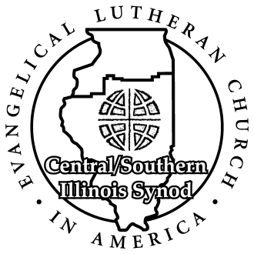
Central / Southern Illinois Synod
524 South Fifth Street Toll-free: 844.330.2747
Springfield IL 62701 Phone: 217.753.7915
Fax: 217.753.7976

May 19, 2020

Dear sisters and brothers in Christ,
God’s rich grace be yours in this Easter season!
Our Synod Council was poised to introduce resolutions to the 2020 Synod Assembly that would have launched several synod-wide initiatives to deepen our faith and enhance our mission and ministry together in Christ’s name. The COVID-19 pandemic has pushed Synod Assembly action off until June 2021.
Our Synod Council believes strongly in these initiatives and their potential for our collective discipleship and doesn’t want to put all of this off for a year. So, the Synod Council has acted to initiate two of these initiatives this year, beginning on Pentecost Sunday: a Dwelling in the Word initiative and a Sister Congregation initiative.
The packet of materials accompanying this letter gives you information on both initiatives, as well as the story of how these initiatives were developed. It is important to see that these initiatives have truly developed from the ground up. They arise directly out of input coming from the 2019 Synod Assembly forums.
The resources in this packet are print and video. These are also available on the synod website. List of contents:
Letter from Carey Mayer and Bishop John Roth
Litany for Launching “Dwelling in the Word” and “Sister Congregation” initiatives
Video story of the development of these initiatives
Video introduction to “Dwelling in the Word” initiative
Video of Synod Council members giving their thoughts on doing “Dwelling in the Word”
Video session of “Dwelling the Word”
Flyer on “Sister Congregation” initiative
Video introduction to “Sister Congregation”
“Sister Congregation” pairings
God bless you as you continue to worship our Lord and Savior. We hope that you will embrace these initiatives in the spirit in which we commend them to you. If you have any questions about this, please contact any Synod Council member.
Yours in Christ,
Carey Mayer S. John Roth
Vice President Bishop
Central/Southern Illinois Synod Central/Southern Illinois Synod
ELCA ELCA

